## horizontal line

## **Minimum Time Traversal**

# **Problem Statements :**

**Distance:** The distance between two points in a grid based on a strictly horizontal and/or vertical path (i.e along the grid lines), as opposed to the **Manhattan Distance** or **Diagonal Distance.**

The **Manhattan Distance** is the simple sum of the horizontal and vertical components, where as the **Diagonal Distance** might be computed by applying the **Pythagorean Theorem.**

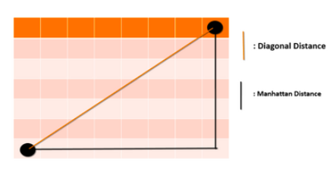

A robot is moving on co-ordinate axis. Time taken to move from one point to another point is equal to the Manhattan Distance.

Ex. Time taken to move from point ( x1 , y1) to ( x2 , y2) is |x1 - x2| + |y1 - y2| where | a | is equal to modulus function of a.

Starting Point (S) and Ending Point (E) of the robot is fixed. There are n wormhole like pipelines also on the coordinate axis. Time taken to move from one point to another point of each pipeline is given.

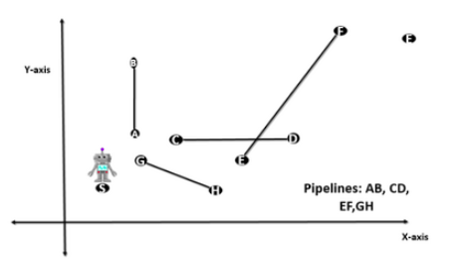

Robot can use those pipelines to move from statring point to ending point. Can you help to find the minimum time required during traversal.

# **Input Format :**

The first line contains T, the number of test cases.

The description of T test cases follows.

The first line of each test case contains integer n which represents the number of pipelines.

The next line contains four space seperated integer. The first two integer is the x and y coordinate of starting point and last two integer is the x and y coordinate of the ending points. The next n lines contains 5 space-separated character x1 , y1, x2 , y2, t . The first four integers are the x and y co-ordinate of terminal of the pipelines and 5 th integer is time to cross that pipelines .

**Constraints :**

1 <= T <= 30  
0 <= n <= 5  
1 <= x,y <= 2000

**Output Format :**

For each test case you have to print the output in this format (#Test Case Number : minimum time taken by robot to traverse from begining to ending point.)

# **Sample Input :**

3  
0  
20 20 100 100  
1  
20 20 100 100  
25 25 30 30 5  
3  
20 20 100 100  
35 35 50 50 0  
30 30 25 25 0  
40 40 60 60 100

**Sample Output :**

#1 : 160  
#2 : 155  
#3 : 120

**Explanation :**

For test case 1: time = |20-100| + |20-100| = 160

For test case 2: Robot use pipeline => (20,20) --> (25, 25) -->(30,30) --> (100,100) , Total time = |20-25| +|20-25| + 5 + |30-100|+|30-100| = 155

**Time Limit :**

none